In order to maintain the application data after exit a relational database must be embedded in the application. Android allows the creation and use of an SQL database through what is called a content provider. As with all relational databases the database entities must be normalized to maintain data consistency. The following database entities have been deduced from normalisation:

- Workout
- Exercise
- Exercise Record
- Scheduler

The application must be able to access the following data from the database:

- Workout
  - Day
  - Muscle Group
  - Exercises in that workout

- Exercise
  - Name
  - Rest period
  - Photo URI

- Exercise Instance
  - Exercise name
  - Date
  - Result

The application must be able to perform the following functions on the database:

- Add / Remove a workout.
- Add / Remove an exercise.
- Record the results of an exercise / workout.
- Access all of the above data.

Table Normalisation:

From the initial description the following structure with the following functional dependencies was deduced:
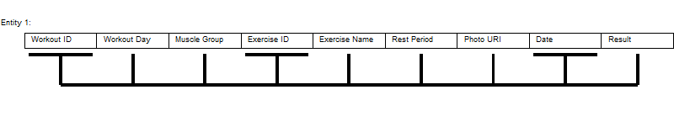
Entity 1. From the workout ID, exercise ID and the date it is possible to determine all other entries.

It can be seen above that Entity 1 is in need of normalisation as it has multiple functional dependancies.
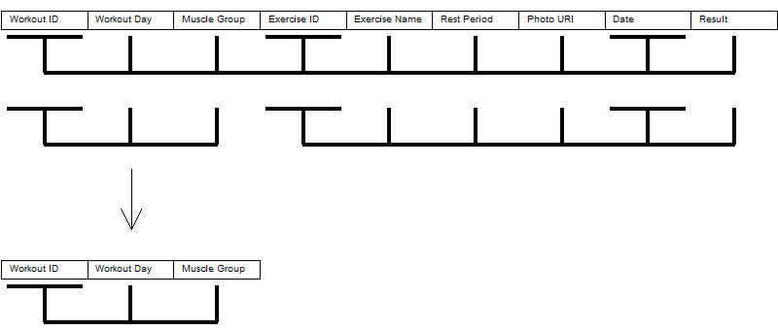

From this initial normalisation we now have an entity in BCNF. This will be the “Workout” entity.

The remaining table still needs further normalisation:

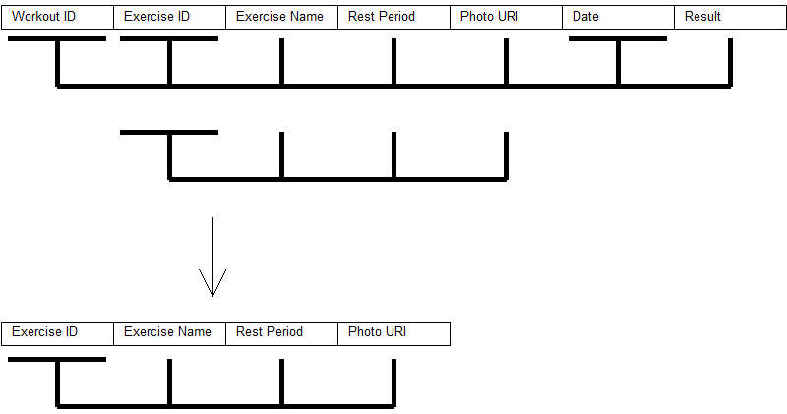

We now have another entity normalised to BCNF, this will be called the “Exercise” entity. The remaining table still needs further normalisation:

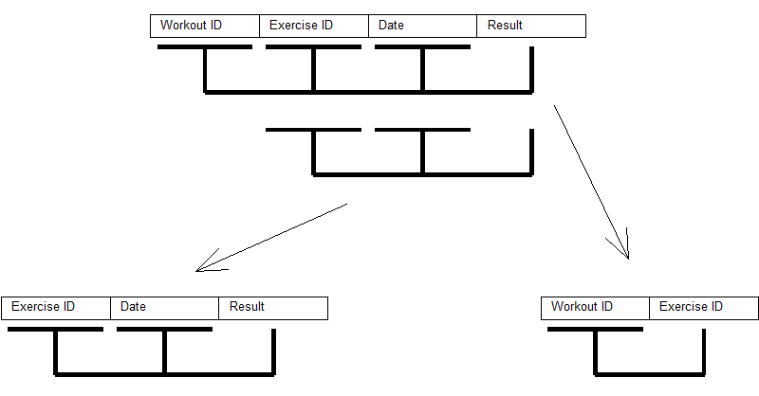

With the above process of normalisation we can now describe all entities in the database:

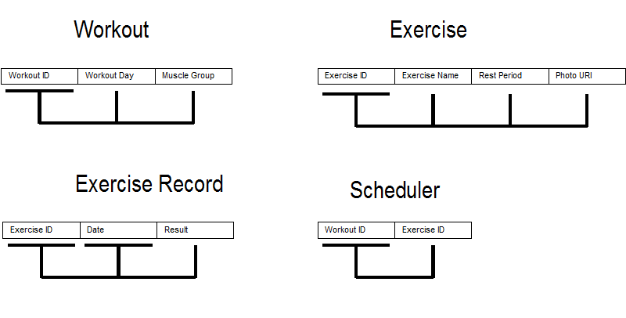

With the above entities we are able to avoid all update, insert and delete anomalies. All entities are in BCNF. The “Scheduler” entity will act as a linker between the “Workout” and “Exercise” entities and will have a many to one relationship with each to avoid them having a many to many relationship with each other (see the EAR diagram later).

Final Entities:

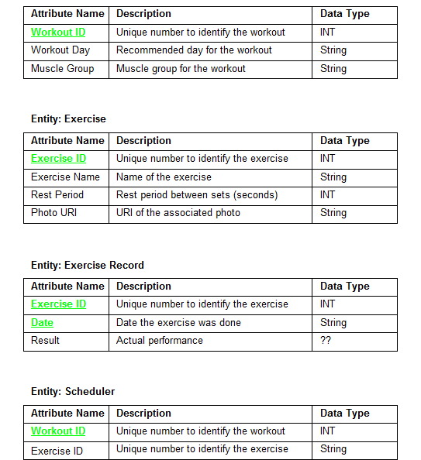

The above entities are a preliminary specification of the database. There are still a few unknown factors as the operation of the android content provider is still not fully understood. In the “Exercise Record” entity it can be seen that the “Result” element has not been defined yet. This element must represent performance in terms of the number of sets completed, the number of reps on each set and the rest period after each set. This could be realised with multiple string elements but there may be a better way of doing this, hence further research and development is needed before this can be finalised.

RI Diagram:

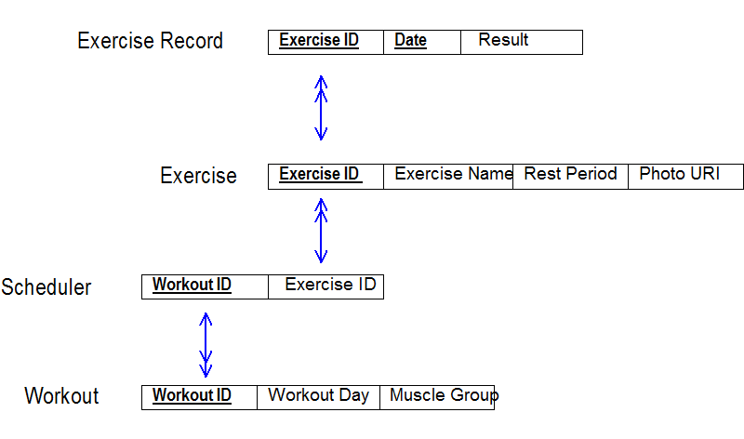

EAR Diagram:

